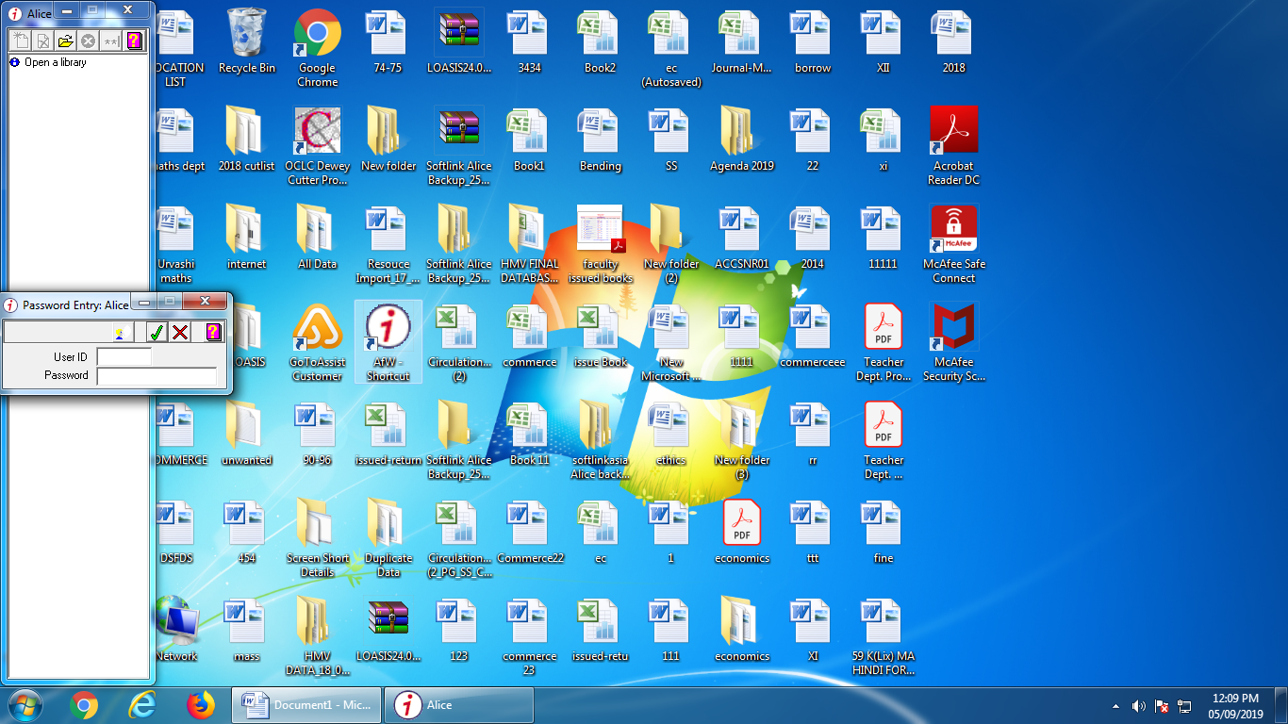
Library Software Name: Alice for Window (AfW)
Alice for window integrated library automations software package is the product of Softlink. Softlink has been exclusively dedicated to the development & support of Advanced Knowledge, content and integrated library management solutions for more than 25 years. Softlink successfully contributes to the goals of organizations across the globe, currently supporting more than 10,000 organizations across 108 nations. Alice for windows is product of Softlink Established in Brisbane, Australia.

Folder Purpose / Functions
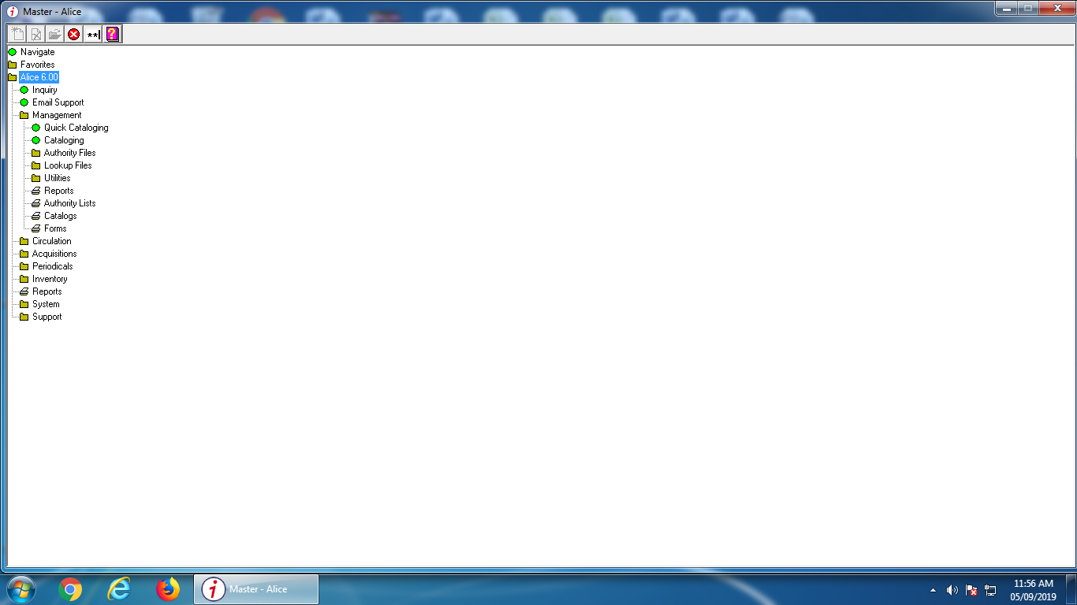
Favourites : Frequently used options may be inserted here
Inquiry : Searching for resources and their availability; reserving resources.
Management : Maintenance of Authority files, including subjects, GMD, authors, keywords, stop words, locations, etc. Cataloguing and accessioning all resources. Printing of reports, authority file lists and catalogues
Circulation : Maintenance of borrower information, calendar, resource and borrower loan categories, fines, user group updating. Circulation of resources, including loans, returns, reservations and bookings. Printing of reports, e.g. overdue notices, borrower lists, borrower and resource usage.
Acquisitions : Maintenance of budget information, the Wish List, On Approvals, ordering, receipt of resources and non-book expenses. Printing of budget reports, orders and On Approval requests, resources by budget dissection and claims for late orders.
Periodicals : Maintenance of periodical titles, subscription information, receipt and circulation of periodicals. Printing of reports, e.g. subscriptions due, claims for missing and overdue issues and circulation lists.
Stocktake : Stocktaking of collection. Includes reports for missing, disposed and purged items.
Reports : Printing all AfW reports, including catalogue reports, overdue notices, loan history, borrower lists etc. The reports folder contains the collective reports that are available within each individual folder.
System : System Administration functions, including system parameters (including Maps), shutdown settings, rebuilds, maintenance of security, operators & passwords, data loading for borrower records and MARC records.
Support : Functions accessible only via the Support Password, including Run, File Compressor and Recovery.
Library Parameters
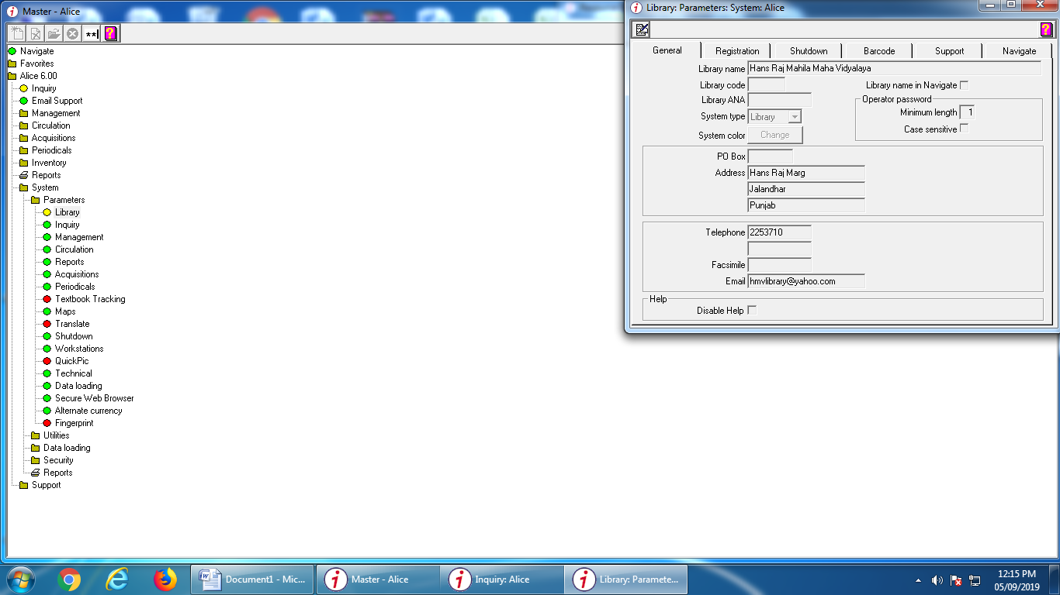
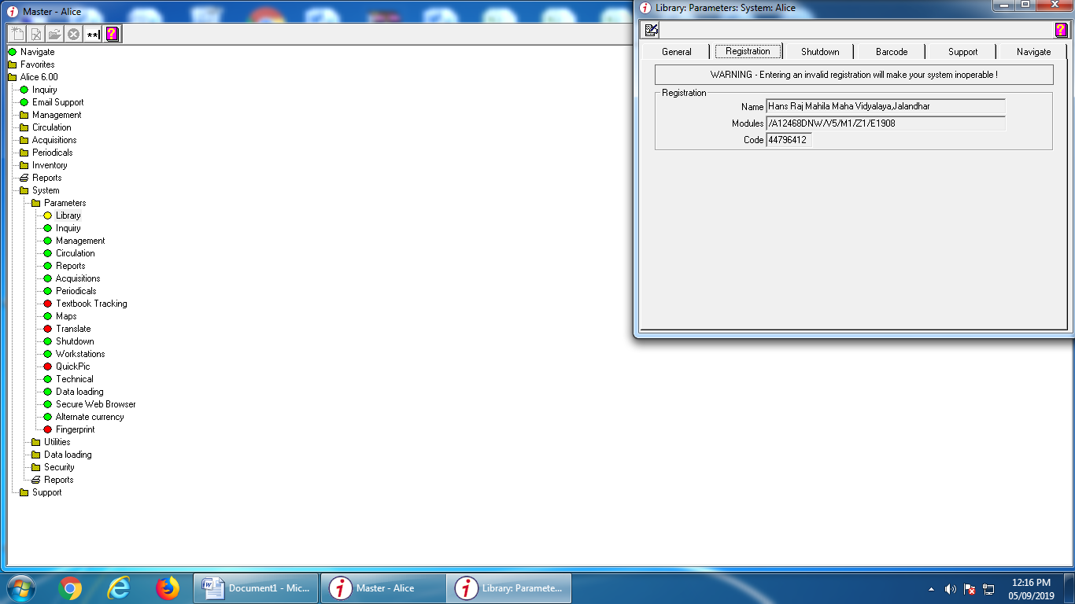

Inquiry:
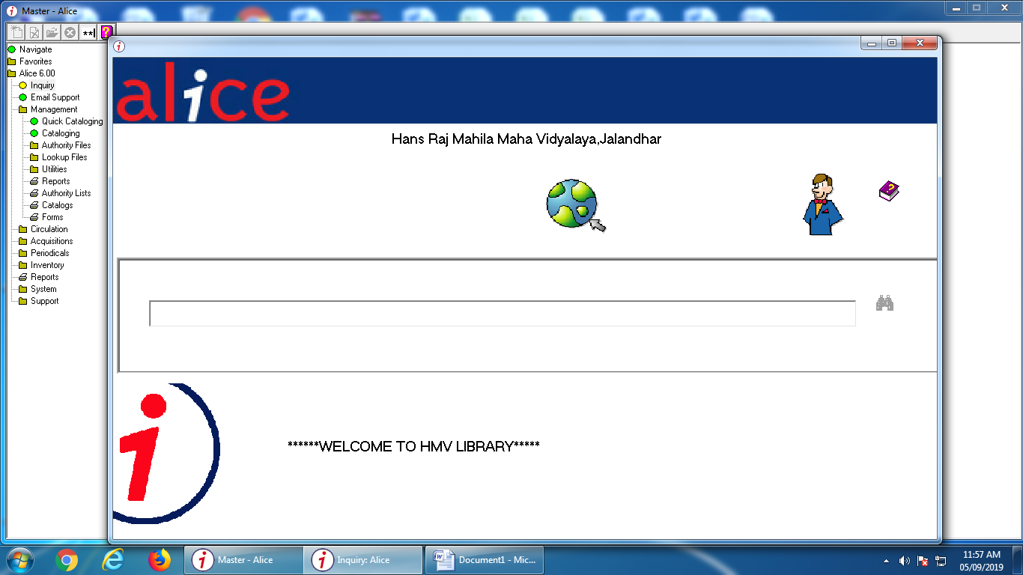
Inquiry with Keyword:
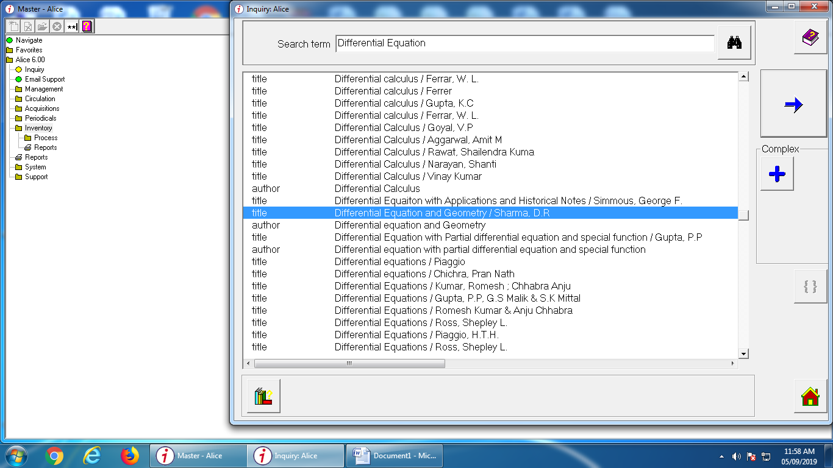

Cataloging Management:
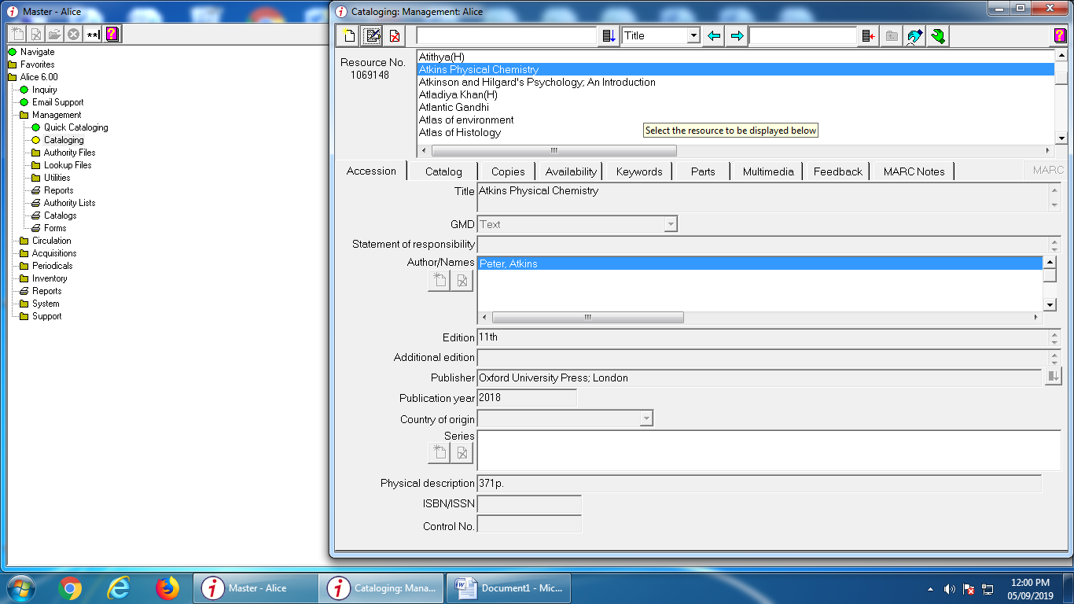

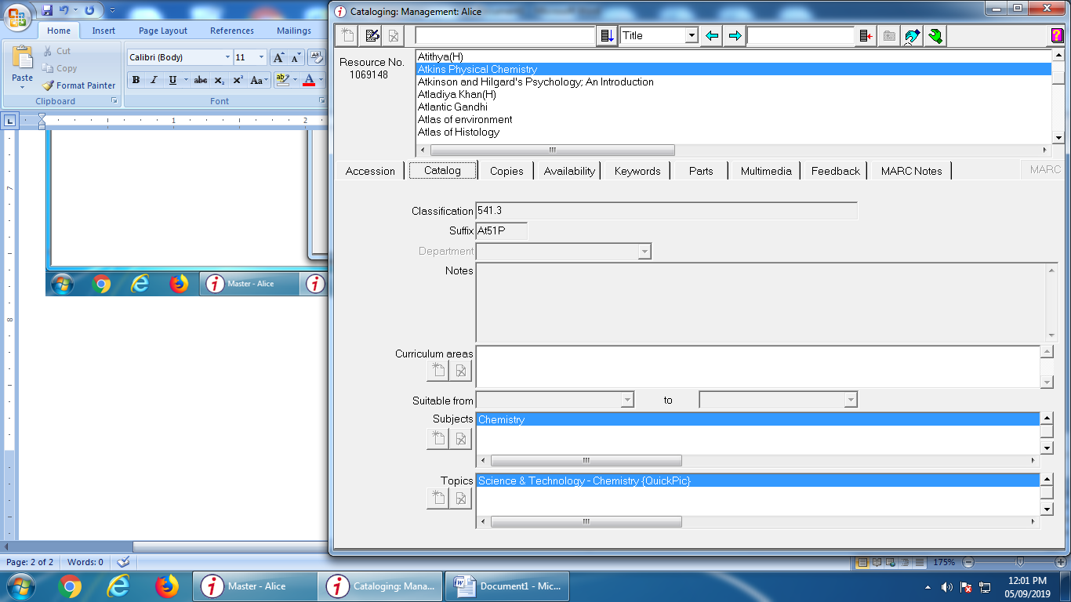

Circulation: Loan
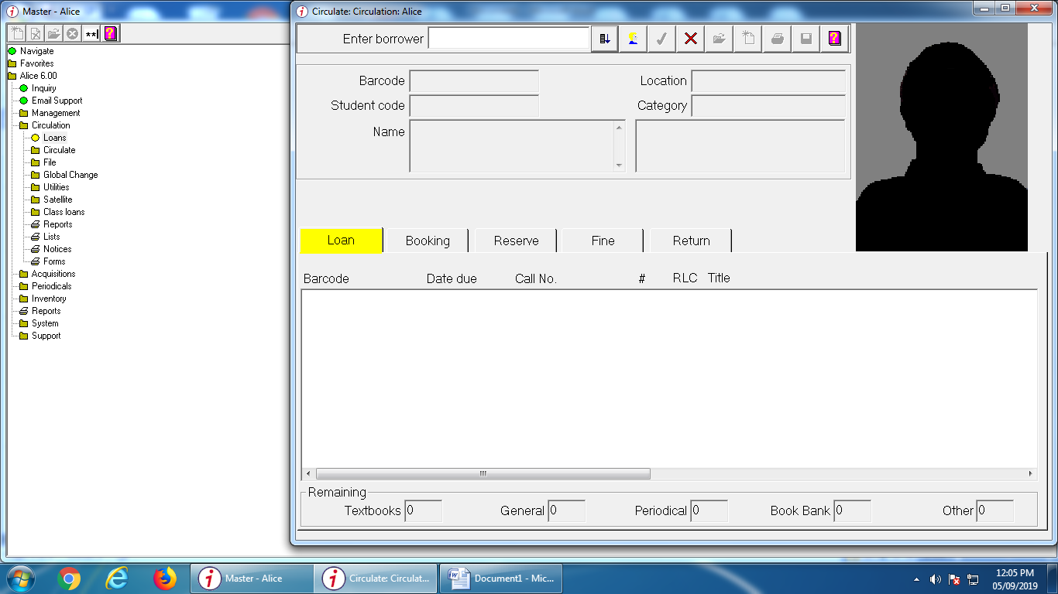
Borrower
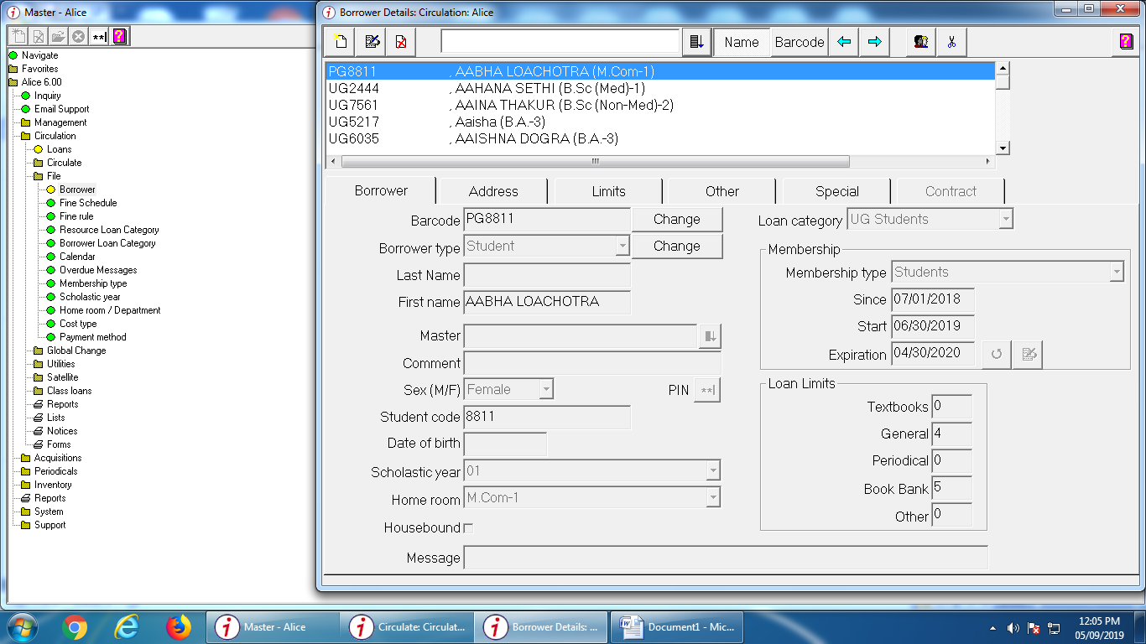

Loan Statistics by Borrowers
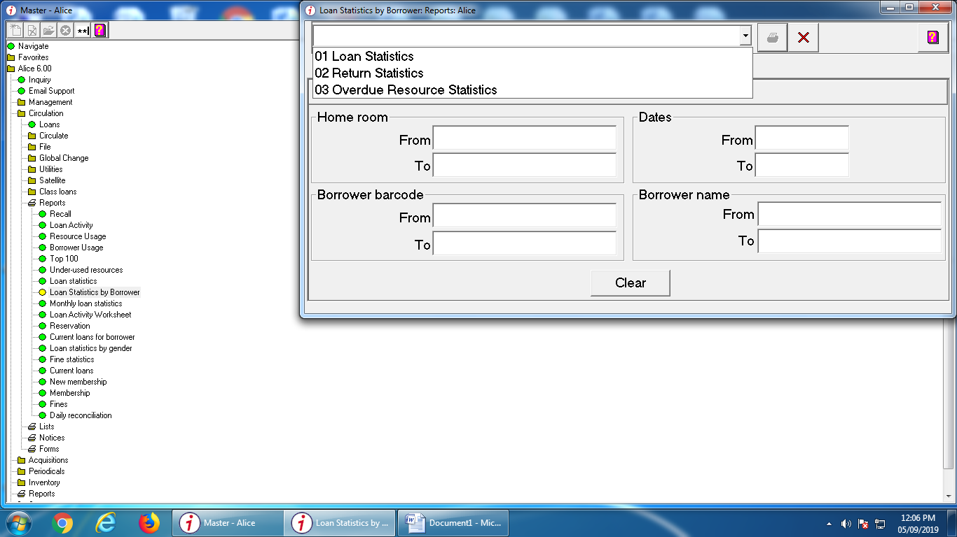
Fine Statistics
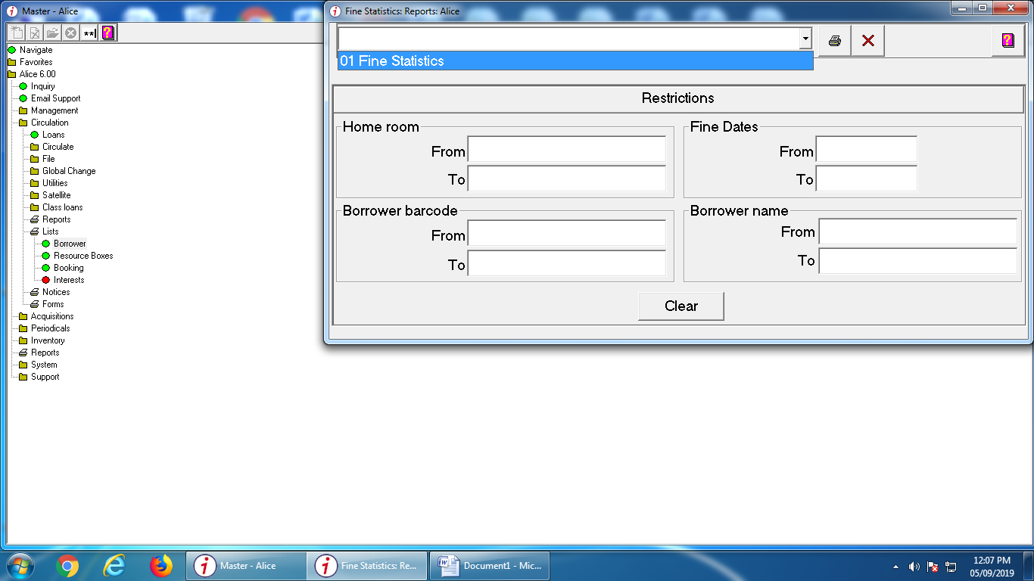

User Report
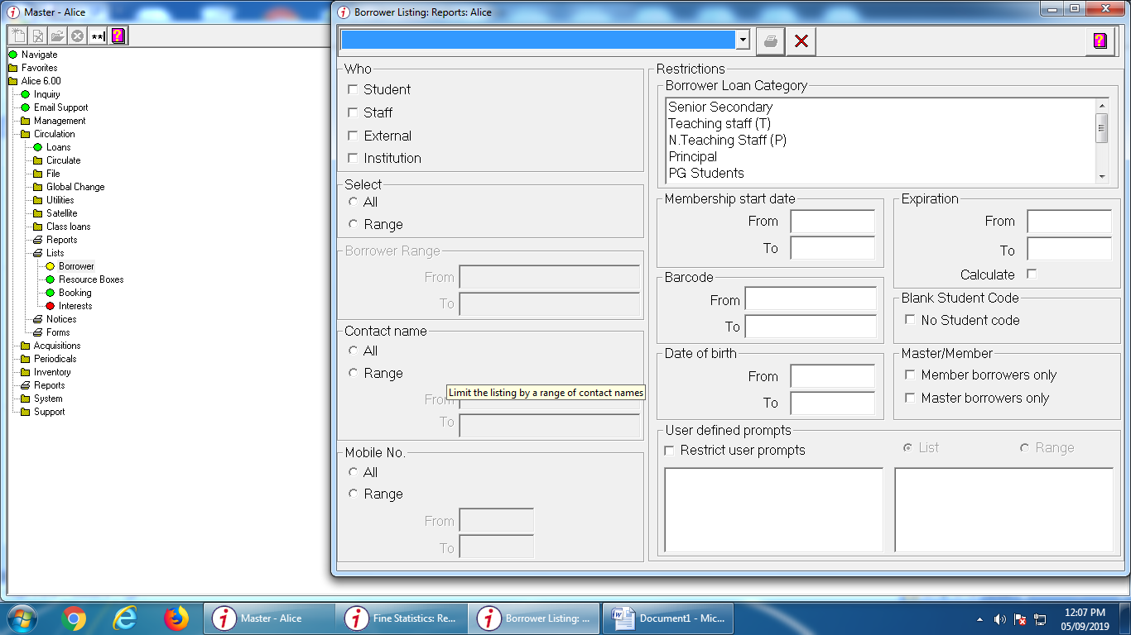

Logout of AfW
